SCHAP SPECIALTY MACHINE SEAM FATIGUE TESTER
INSTRUCTIONS ON SETTING THE TEST WIDTH
We have supplied a bar with your tester that has 120mm and 140 mm marked on it. These bars are used to set the width of the sample between the clamps for your test. As you can see on the picture below, you use the bar to HOLD the clamps apart by the exact dimension needed for your sample. Once you have the bar in place, you may insert the sample and then use the knobs to apply pressure to hole the clamps in place. See picture below.
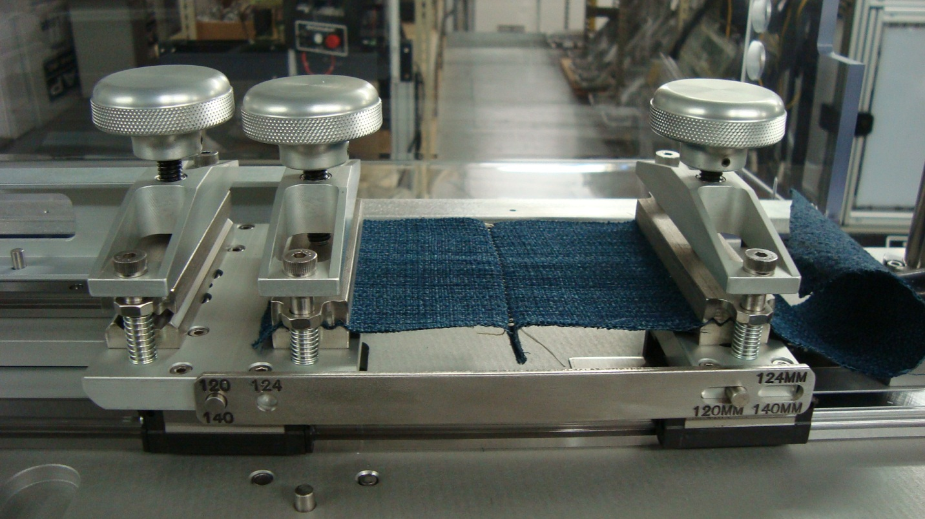
In the picture you can see the bar (RED arrow), the clamps (GREEN arrows), and the knobs to apply pressure (YELLOW ARROWS). After you have installed the sample, you can return the bar to the holding location on top of the tester (see photo below).
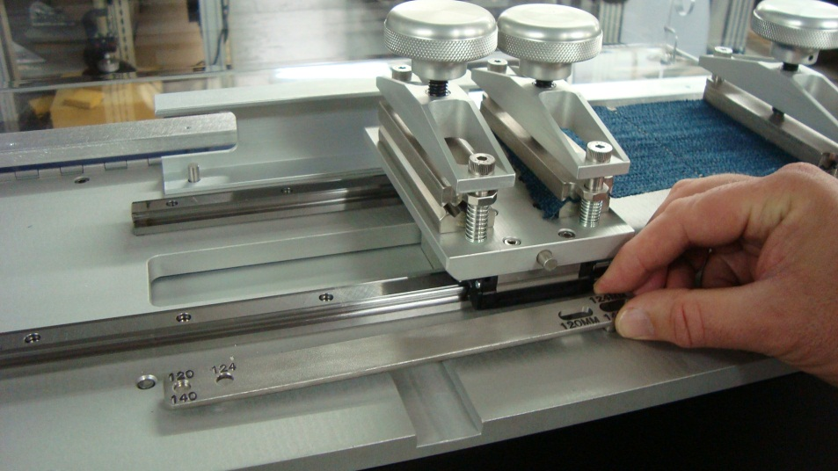
SCHAP SPECIALTY MACHINE SEAM FATIGUE TESTER
SETTING THE WEIGHTS FOR THE GM TEST
The tester comes with the weights pre-installed so that you do not need to move anything, except for the GM test. To meet the GM test requirements, you have to LIFT the end bars of the tester as shown below.
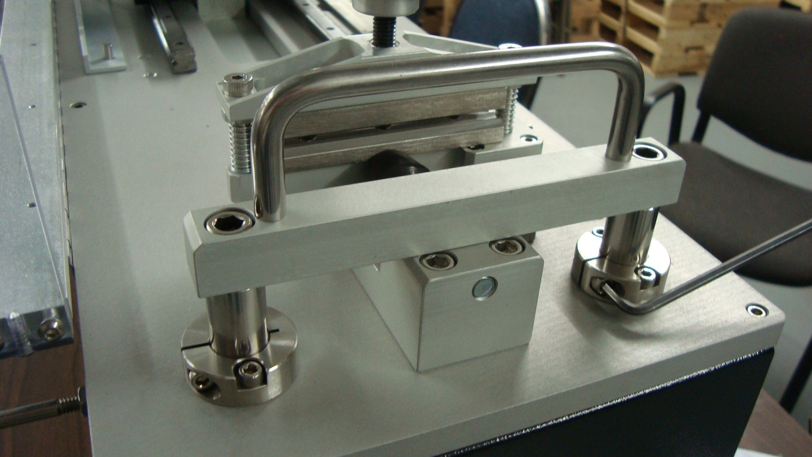
You can see that the bar is in the LOWER (down) position as received. There are two clamp collars located on each of the ends of the bar. Using an Allen wrench, loosen the screws holding the clamp in place. Once you have loosened both of the clam collars, the bar should pull up and you then have the test set up for the GM requirements (see photo below).
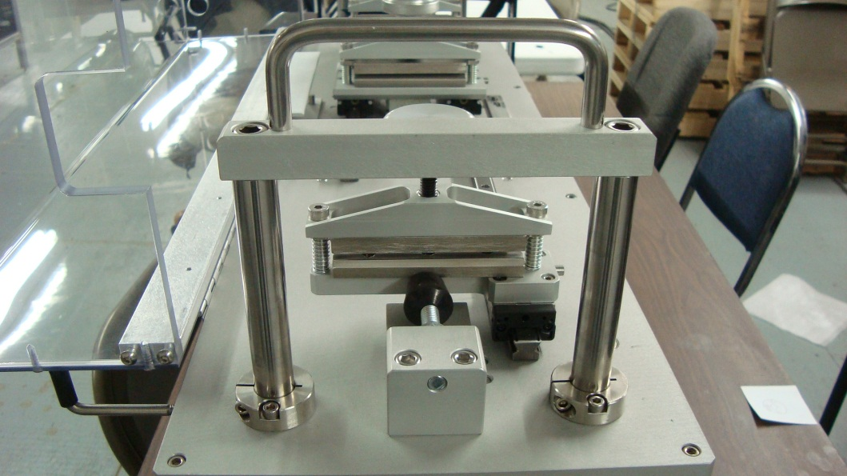
These bars have the weights attached to them. Once you have BOTH bars raised, you then need to tighten the clamp collars again to hole the bars in the raised position. (See photo)
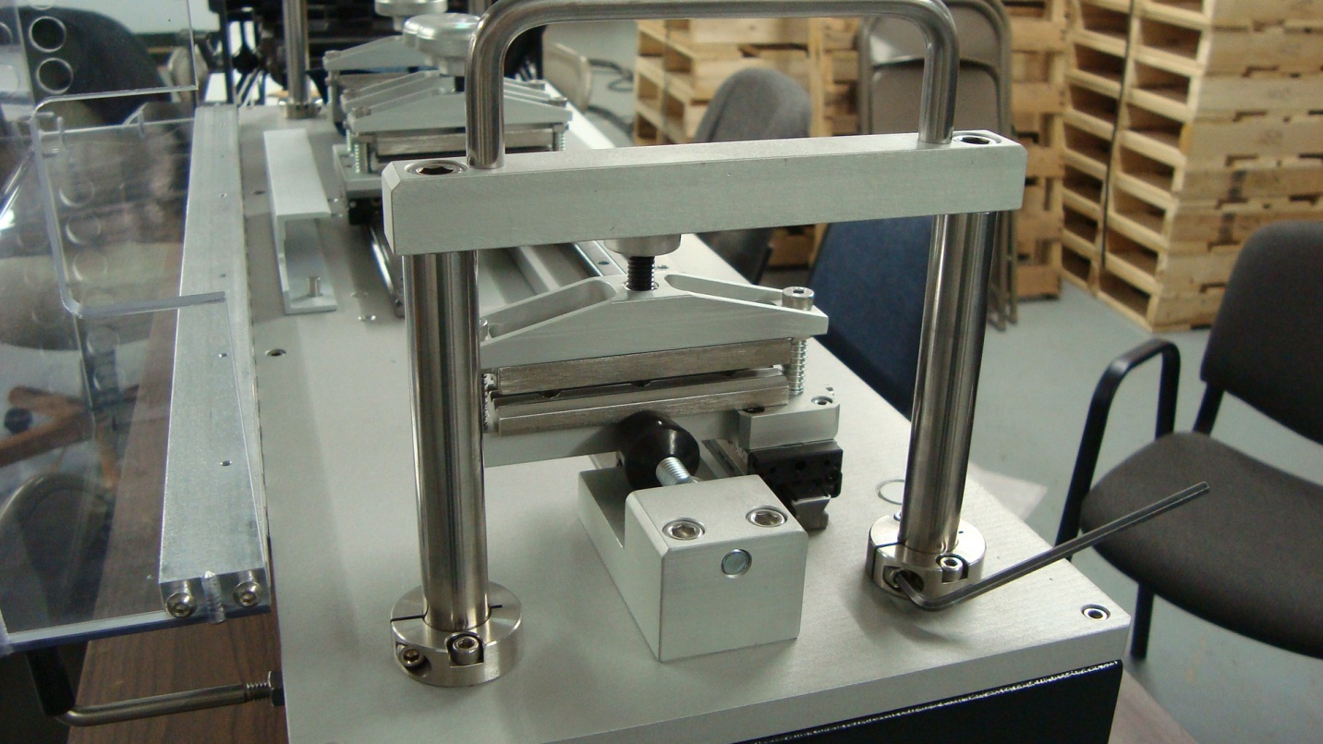

You are now able to conduct the GM test as required.

