17309 Taft Road Spring Lake, MI 49456_______________________ Ph. (616)-846-6530

HONDA ODOR TESTER OPERATING INSTRUCTIONS

Prior to Use:

- Connect the tester to 110V AC power using the provided cord.
- Connect the nitrogen supply via the barbed fitting on the back of the tester.

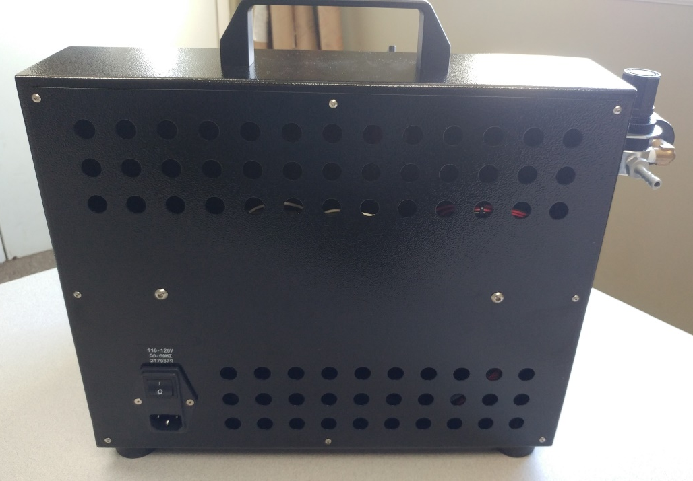
Nitrogen Input
Power Receptacle & Switch

- Use the pressure regulator to reduce incoming pressure. Note: Do not exceed 75psi of outgoing pressure.

Usage:

- Select the correct diameter brass fittings for both the vacuum & nitrogen ports. Two blank fittings for each port are provided. These can be drilled to the correct diameter for the fill stem on your bag.
- Power the tester on via the Power Switch on the back of the machine.
- Verify the flow of nitrogen by clicking the “Fill” selector to either setting.
- Adjust the flow meter via the green knob on the front. It should read 6L/min when adjusted. Note: Changing incoming pressure will change flow rate.
- Insert and hold the fill stem of the sample bag into the vacuum port of the tester. Open the bag valve. Press and hold the vacuum button until the bag is sufficiently evacuated. Close the bag valve. Remove the fill stem from the vacuum port.
- Insert and hold the fill stem of the sample bag into the nitrogen port of the tester. Open the bag valve. Select 2L or 3L of nitrogen to be filled via the selector switch. Filling is controlled based on time. Once the flow meter is showing zero, close the bag valve. Remove the fill stem from the fill port.

Adjusting the Timers:

- Power down and unplug all connections to the tester.
- Remove the eight screws in the back panel.
- Allow the panel to lie back on the bench. Note: Do not pull on the back panel as it could damage electrical connections.
- Rotate the clear cover of either timer as desired. This will change how long each fill lasts.
- Support the panel and reinsert all of the screws.
- Reconnect the tester to power and nitrogen.

